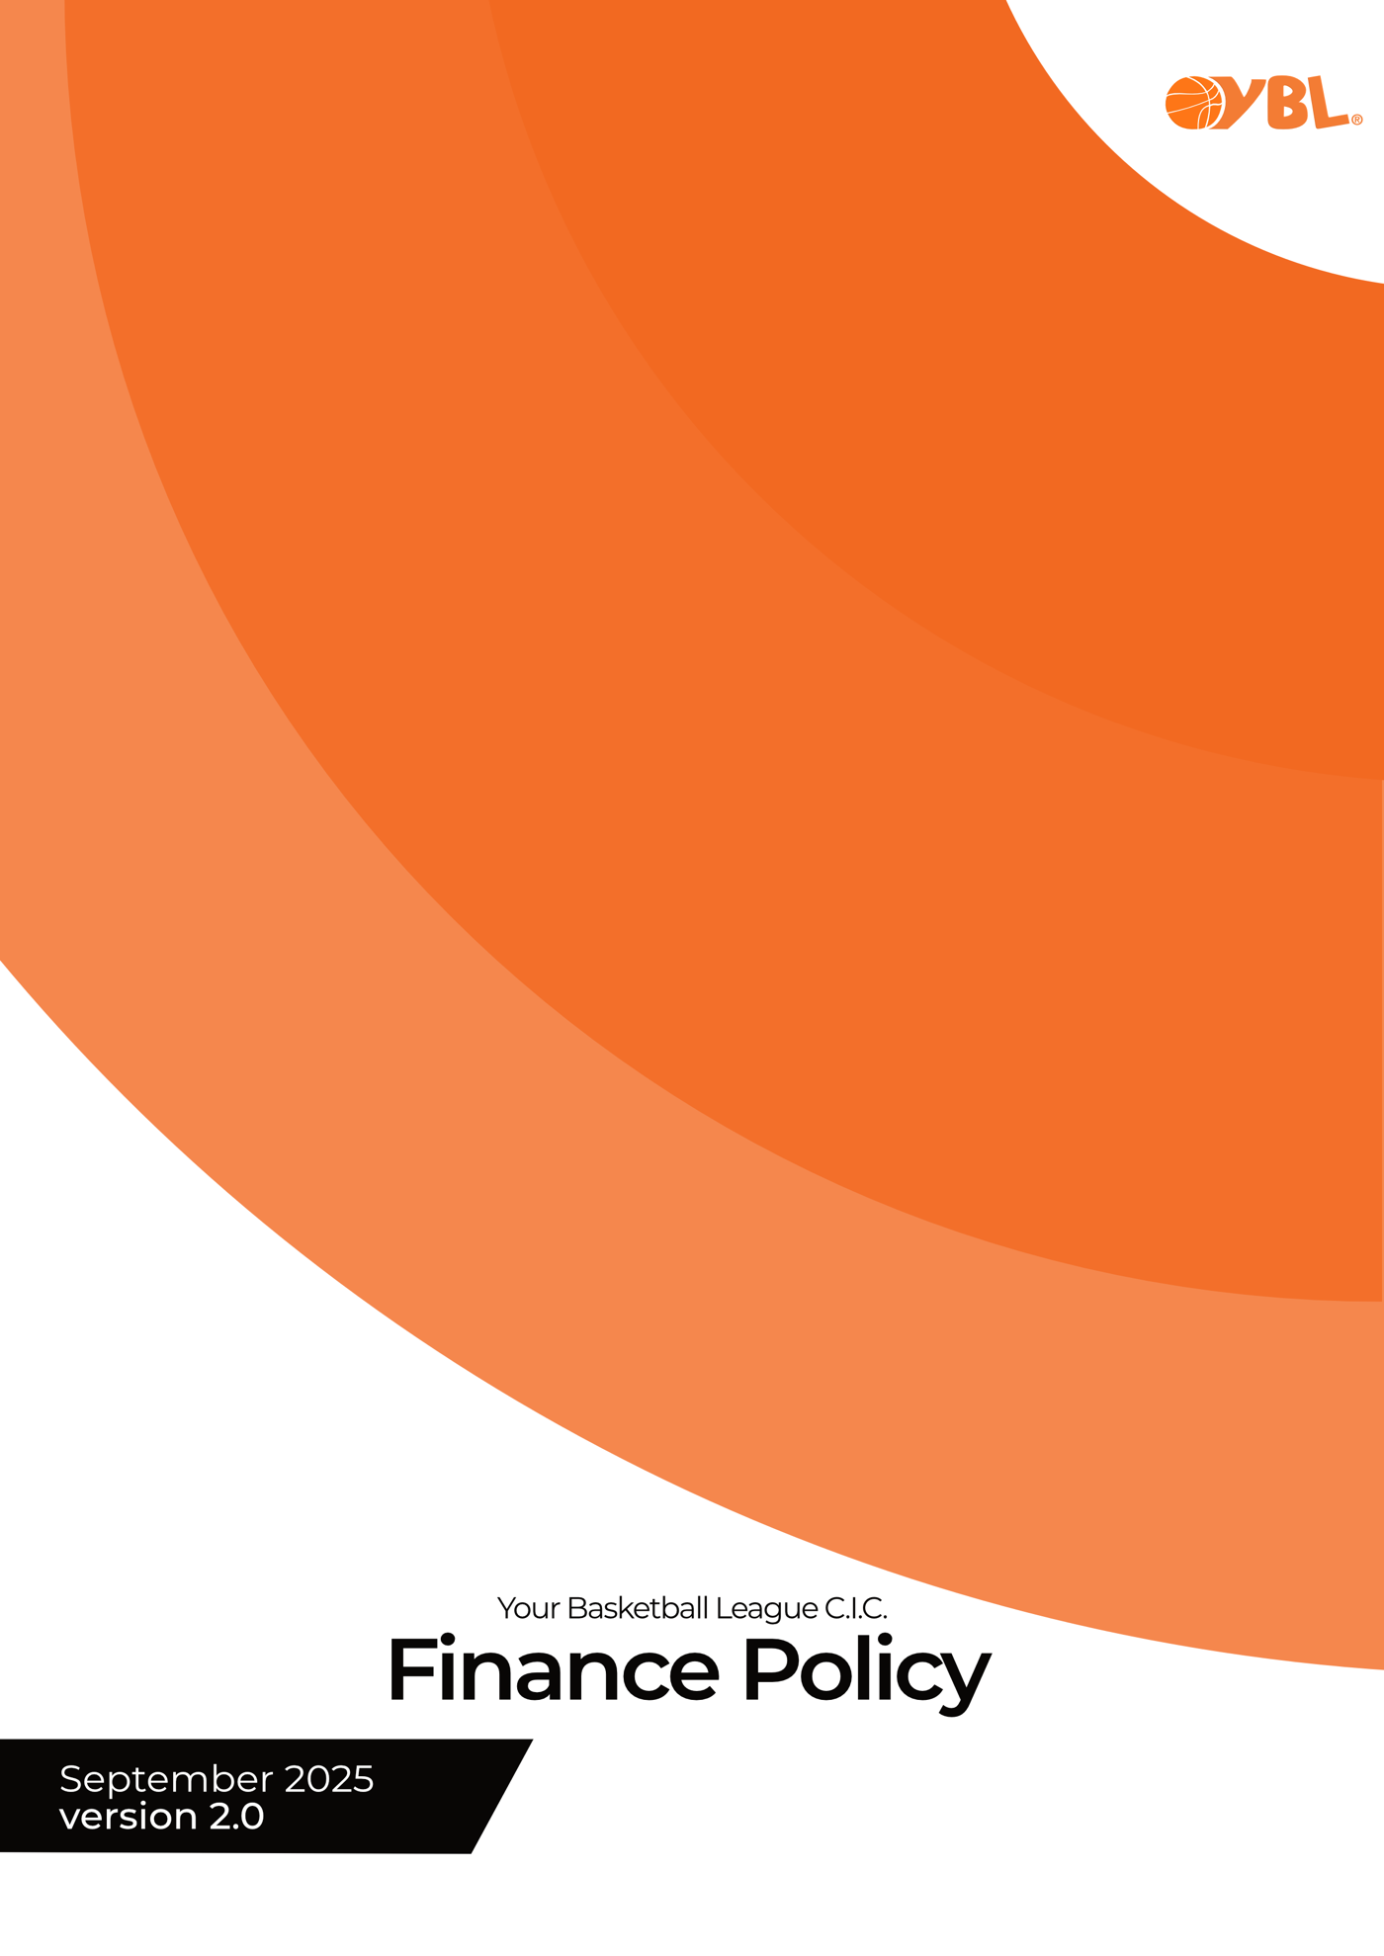

Finance Policy

Payments
All payments to the YBL must be paid by the date indicated, either issued invoice or by any electrical payment system used.
Any outstanding balances that remain unpaid after 28 days will automictically be increased by 25%. The YBL will contact the club by the Club Secretary, via email or phone regarding non-payment.
Any player sanctions that result in that individual receiving a financial penalty will be issued through the club. An outstanding invoice for any player will result in them being unable to participate at any level within the YBL until the payment has been received.
We reserve the right to postpone/cancel or eject a player, team or club from the league if all reasonable steps have been taken by us to resolve any outstanding payments.
You may not enter any YBL leagues for the following season until all outstanding payments due are brought up to date.
We may share this information with governing bodies or regional committees if appropriate.
If any individual, team, or club have difficulties with payments please speak to a member of the YBL team to prevent any possible sanctions.

Refunds
Team withdrawal prior to the season, the first game played in any competition, will be entitled to a full refund at the discretion of the Board of Directors. Team withdrawal after the publication of fixtures for the forthcoming season will not be entitled.
However, we will consider appeals on a case-by-case basis.
Payments from the YBL will be by BACs transfer only.

As we are a volunteer organisation, any refunds will be processed as quickly as possible, we aim to get this completed within 28 days of the request being approved. You must provide your clubs full bank account details. Failure to do this may delay your refund.

YBL Bank Details  Lloyds Bank Plc  30-96-12 sort-code  63680668 account number | YBL Legal Information  Registered in England & Wales, company number 10776305.  Registered address 16 Crompton Road, Frankley, Birmingham. B45 0LH.  All rights reserved.  The YBL logo is a registered trademark.  Permission is granted for any clubs participating within the YBL to use the YBL logo on their playing kit and on any club website to link to the YBL. If you wish to use the YBL logo for any other purpose, please seek Board of Directors approval.

